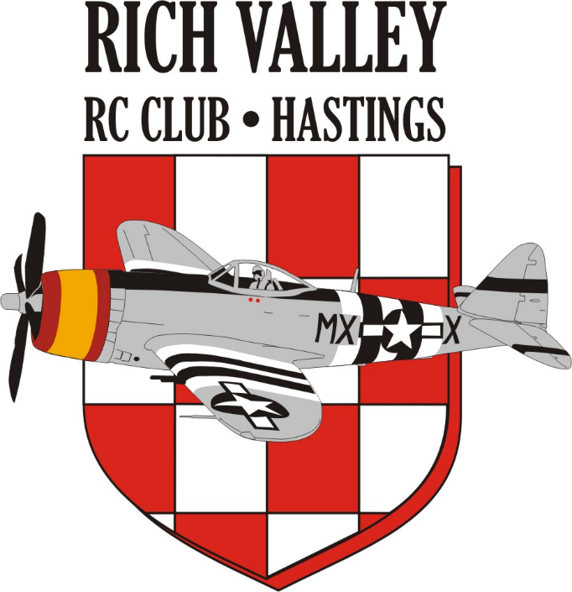
Rich Valley Radio Control (RVRC) Club Field Rules
(These rules are in addition to the current AMA rules)
- Only current Rich Valley R/C Club members and accompanied guests with current AMA membership cards may use this field.

- New members must be sponsored by an existing RVRC Club member. The sponsor’s responsibility is to acquaint the new member with RVRC Club rules pertaining to R/C flight and common field practices, i.e., frequency board use, flight station usage, review of the AMA rules, etc. A Flight Safety Checklist will be available for this purpose. This orientation must be completed prior to the new members’ first flight.

- All radio transmitters at the flying field shall be turned off when not in use.

- When radio transmitters are turned on and/or used for flight, the pilot responsible for this radio will display their RVRC Membership Card containing their name and AMA number by placing it under the corresponding channel number clip on the Frequency Board. Pilots utilizing the 2.4G frequency band will display their card on one of the 2.4G clips located on the bottom of the Frequency Board.

- There shall be no take-offs directly from the pit area, or intentional flights over the pit/designated spectator area. Intentional flight operations over the road and over the residence North of our field must be avoided. In addition, all pilots will avoid flights North of the white post erected in the North-South tree line and will utilize the southernmost flight stations first. Aircraft will not be intentionally flown West of the white pole as this is also considered a pit no fly zone.

- Pilots shall announce their intentions LOUDLY for take-off’s. landings, dead stick, when entering field to retrieve aircraft, etc. Dead stick landings take priority over powered take-offs and landings. All landings take priority over take-offs.

- For the safety of all parties involved, there will be no flying if Baily field workers are present and working in any field location. Regardless of their proximity to the R/C field; if they are visible, all flight operations will be halted or cancelled until they have cleared the farming field(s). Exception: Field workers are not present and Club members are flying: If a Baily service vehicle(s) drives through on the service road, flight safety protocol will apply and Club members will direct their aircraft away from the moving vehicle(s) movement area until the service road is clear.

- Aircraft started in the pit area must be physically restrained. No engine running in the pit area will exceed idle RPM unless positioned in the first row closest to the runway and facing the runway. Members should consider making mixture and other engine adjustments in a safe area outside of the pit area. No aircraft will be taxied under power in/out or through the pit area.

- All pilots shall use a designated flight station during all flight activities. Combat heats are excluded.

- There shall be no flying or engine starting of nitro/gas powered aircraft before 8:00 AM or after dusk. Electric powered aircraft are excluded.

- Flights shall be limited to 15 minutes when other pilots are present.

- There shall be no more than 4 (four) aircraft in the air at one time, except during designated combat heats, at which time the number shall not exceed 8 (eight) aircraft.
- For safety reasons pets are not allowed at the field at any time.

- Visitors shall be confined to the designated spectator area or the parking lot unless escorted by a Rich Valley R/C Club member.

- All nitro/gas powered aircraft shall have mufflers. The maximum sound level selected by the membership is 95db measured at 9 ft with the Club sound meter. Aircraft whose average tested dB level exceeds 95 @ 9 feet may not be flown at the Rich Valley RC Field without the utilization of a spotter equipped with an audible alarm. The spotter shall be positioned so as to be able to warn the pilot when his aircraft is approaching or beyond the white pole erected on the East-West tree line.

- All members are responsible to dispose of their own litter or other debris.

- Members will not set their pit area up outside of the fenced pit area unless the established pit area is too congested to facilitate safe operations. In the case of over congestion, a pilot’s meeting will be held and a safe area outside of the fence will be determined. No one is allowed to pit directly behind the roped parking area.

- Model rockets and line control aircraft are not allowed to operate at the Club field. Gliders and sailplanes utilizing a bungee launch process are allowed but shall be located at the southernmost part of the field as not to conflict with powered flight operations. Bungee cord operations and/or tow lines shall not impede the take-off or landing path of powered aircraft.

- Helicopters and Drones are allowed to be flown at this field. Any pilot planning to fly these aircraft shall have a briefing with the fixed wing pilots at the field to make them aware of their intentions. Helicopter and Drone flights will be allowed their own clear air time. Safety protocol requires fixed wing flights to be grounded to allow unobstructed rotorcraft flight until completed.

- If any member suffers a loss due to another members’ failure to abide by these rules, the offending member shall be responsible for the victim’s loss, and shall satisfy the victim in a mutually agreed upon manner. If a solution can’t be reached, one may be suggested by the Club officers.

Adopted February 2021, Revised May 2024

